**Promotional Items:**

* [Gadget Spinner](https://www.marcopromotionalproducts.com/Product/Gadget-Spinner---Clearance-GA-18013CL-175802.htm), GA-18013CL (image 1)
* 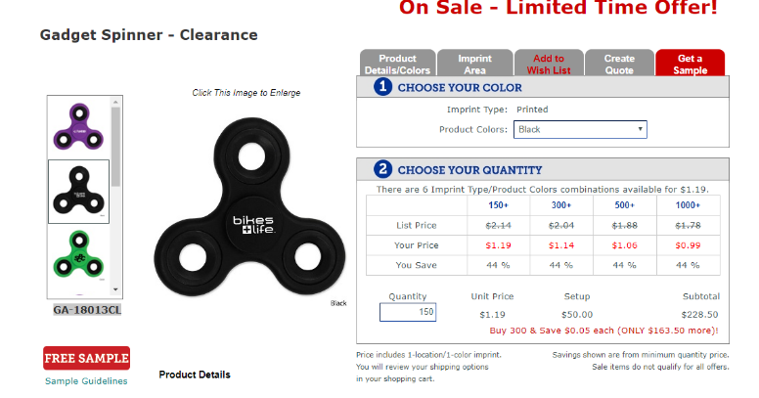[Eco Spiral Notebook & Pen](https://www.marcopromotionalproducts.com/Product/The-Eco-Spiral-Notebook--Pen-WPE-1004-111972.htm), WPE-1004 (image 2)

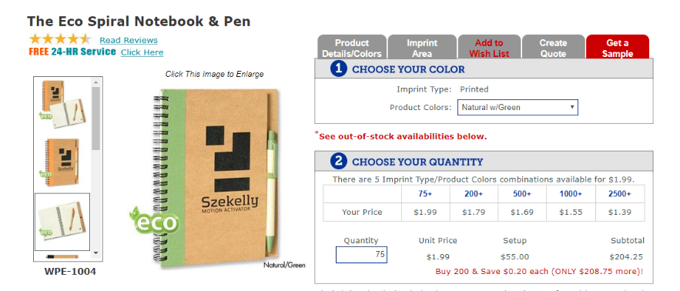

**Uniforms:**

* [Ladies Interlock Cardigan](https://www.sanmar.com/p/7656_DeepBkChaHe#?doScrollToGrid=true), L807, $29.98 (image 1 – far left)
  1. Okay value, thicker material.
* [¼-Zip Sweatshirt with Cadet Collar](https://www.sanmar.com/p/638_Black#?doScrollToGrid=true), 4528M, $27.10 (image 2)
  1. Okay value, going to be thicker material, was one of the originals   
     we were considering last semester.
* [¼-Zip Pullover](https://www.sanmar.com/p/8378_Black#?doScrollToGrid=true), ST357, $15.98 (image 3)
  1. Best value, light weight athletic material.
* [½-Zip Pullover](https://www.sanmar.com/p/5089_Black#?doScrollToGrid=true), F224, $23.98 (image 4 – far right)
  1. Good value, light weight micro fleece material, will be incredibly soft.

